# BIONIC ARM

# Introduction:

Over 3000 years ago, in ancient Egypt, which was the motherland of one of the greatest civilizations, the high priests had a belief. They thought that, while human lives had a finite length, that wasn’t the case with the afterlife. It was eternal and according to the theology of Osiris, the soul would leave the body and return each night to replenish the energy. Hence, there was a need to keep the body full, FOREVER. Thus the ancients developed various prosthetic parts like limbs, noses etc. and kept it in the graves.

From that point in history to peg legs for sailors made of general wood to the present where bionics can be controlled by a person’s mind, humankind has come a long way.

Yet, in spite of all the wondrous advances made by the beautiful minds of our human family, the technologies have not reached every section of the society. Irrespective of all the amazing science out there, poor people who have unfortunately lost their limbs or not been blessed with one at all, are suffering everyday to only survive. There are thousands of little innocent kids, sad old grandmothers and young men with huge dreams who only sleep in the night asking why they couldn’t be the same as other people. Why do they have to suffer?

As young engineers with ample power, support and knowledge to change this depressing situation, we chose to take a step ahead. We aim to develop a project where we can make bionic arms that can be 3D printed, customised to the user’s needs, with simple yet exciting technology but in a much economical fashion than any existing technology.

# Components required

* 3D printer with respective filament
* MG995 servos x3
* Stepper motor
* ULN2003 stepper motor driver
* Myoware Muscle sensor with electrodes x3
* Arduino Uno/Mega
* Required power source (batteries)

# Proposed Design

In any engineering solution we need a input, reading which we take actions, i.e. output and create a closed loop for this process to continue. In case of bionic arms, we cannot ask an amputee to wear an arm that’s plugged into the switch board and restrict his/her movement. We have to give inputs wirelessly. We can achieve that through various modern methods like Bluetooth, Wi-Fi etc. However the fundamental property of bionics is that we use body parts where they are mot present!

As kids we have learned how our biceps and triceps work. When we bend our arm lifting something, the biceps contract and the triceps relax. When we leave our arms freely, triceps stretch out and biceps relax. What if we could use this little piece of information, to control our artificial electronics?

This is when muscle sensors come in!

The Muscle Sensor measures, filters, rectifies, and amplifies the electrical activity of a muscle and produces an analog output signal that can easily be read by a microcontroller, enabling novel, muscle-controlled interfaces. It measures a muscle’s activity by monitoring the electric potential generated by muscle cells. This is referred to as electromyography (EMG). The sensor amplifies and processes the complex electrical activity of a muscle and converts it into a simple analog signal that can easily be read by any microcontroller with an analog-to-digital converter (ADC).

Now the question is which microcontroller shall we use?

We can just use the simplest one, our good old friend ARDUINO.

YES, now we have a brain for our project! But what will that brain run that’ll replicate an arm? We can use a simple system of servos and stepper motors ☺

Let’s take this down step by step…

First we need to 3D print our fingers:

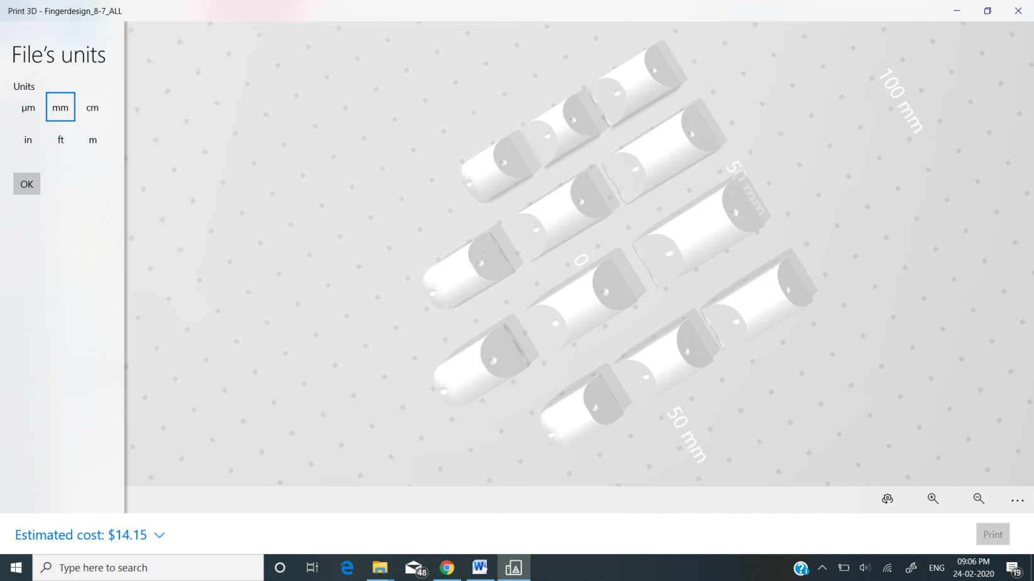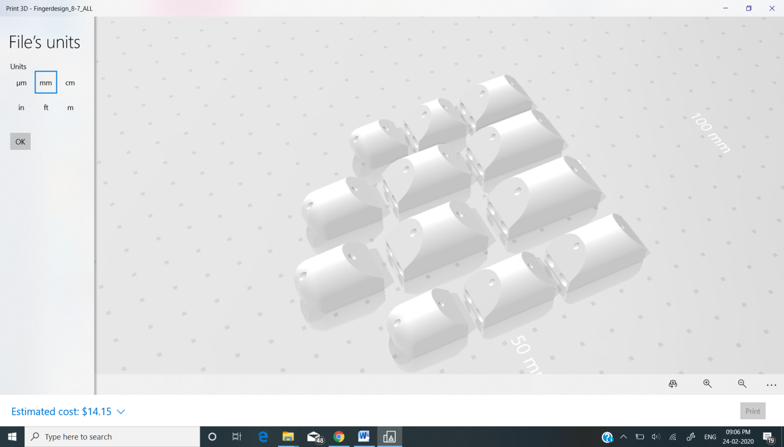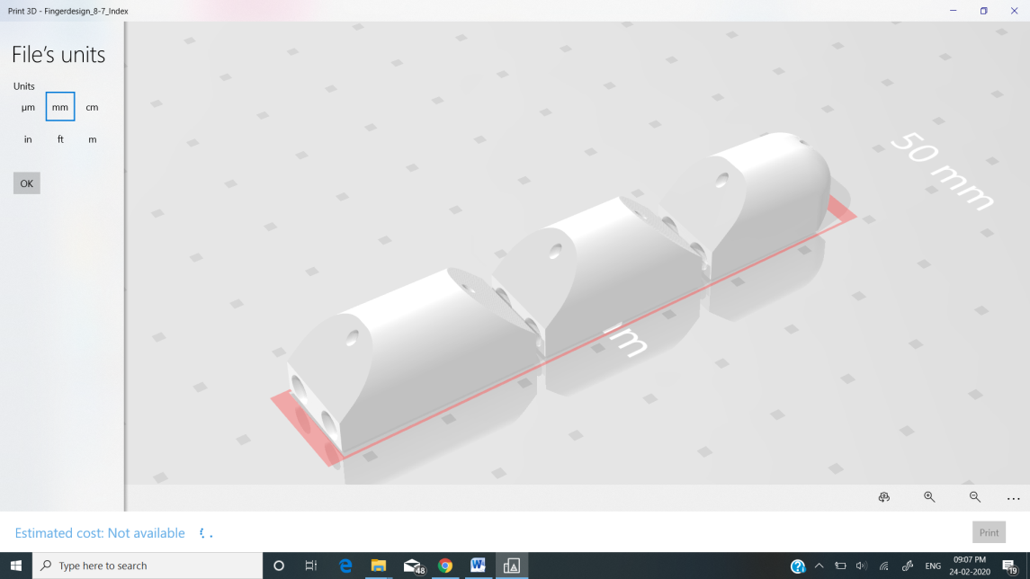

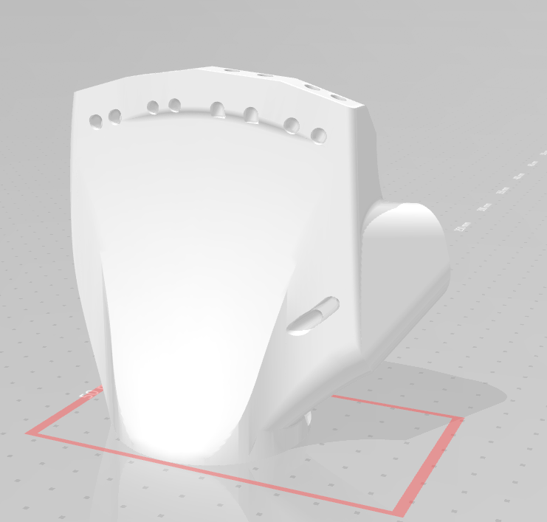As shown in the above designs the system of fingers are made up of rounded cylinders of the dimensions of our finger joints. The two bigger holes are for the support and holdind together of the three parts. The tiny hole that passes through the middle of the 3D printed piece allowsw for a metal wire/fishing threads to pass through. On pulling the fishing threads, the finger opens and closes like real ones.

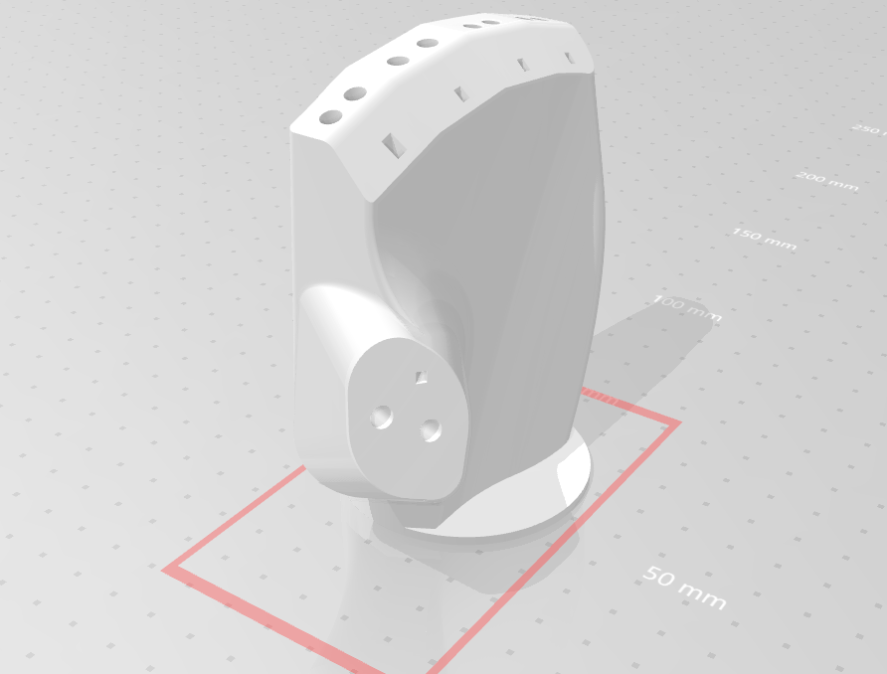

Ropes that hold the figer in one piece comes out through the holes on the backside of the hand. The metal ropes pass through the tiny holes on top of the palm piece and comes down under it.

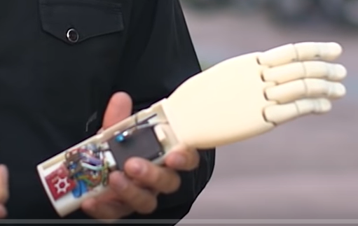

As shown in the above picture the fishing threads that come out are attached to the servo. Thread the fishing line through one of the holes on the servo attchement and tie it off.There are two servos controlling this sytem that sit on top of each other. The thumb line goes through the bottom servo and the the other four lines go through the upper servo.

These servos are attached to the microcontroller which gets inputs from the mylar muscle sensors attached to the microcontroller. From where do we need to take the inputs? One electrode each on the bicep, tricep and the shoulder muscles should account for the lifting action and closing and openning of fingers. However more study with respect to biology point of view needs to be done before implementation.

Now that we have a rough idea of how the 3D printed parts of the bionics work with the electronics, we can draw a rough sketch for the entire arm.

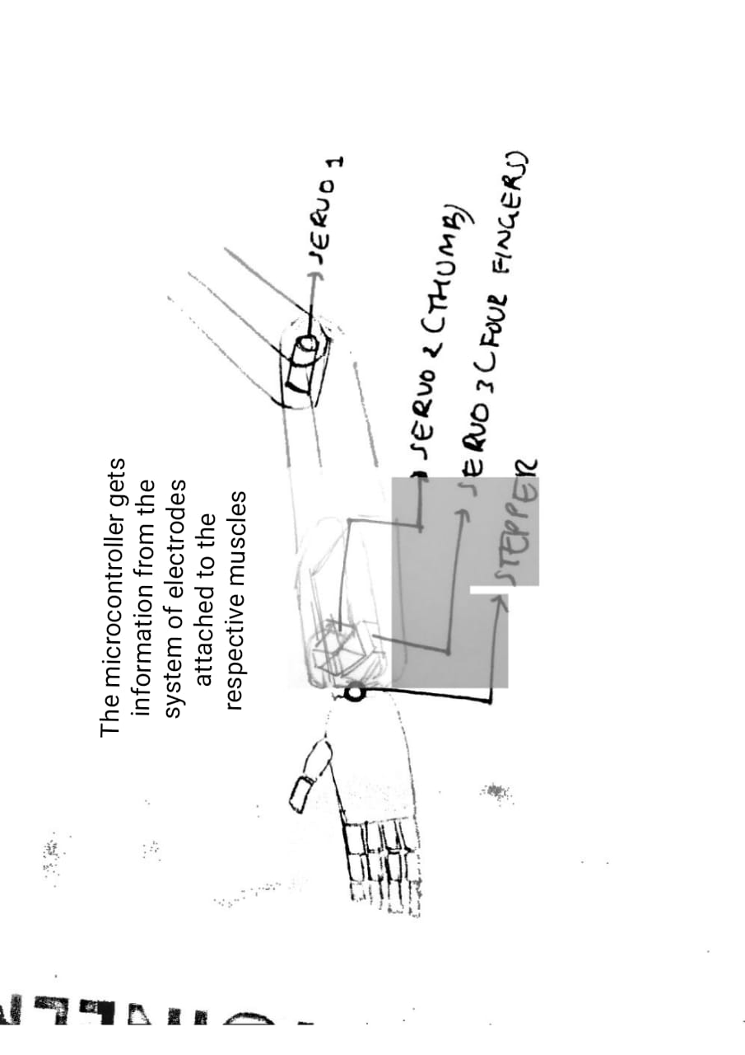

In the end, through thius project, we would like to create heart-warming moments like the following <https://youtu.be/oEx5lmbCKtY> :)

For more information on related topics visit the following sites:

<https://youtu.be/AcLh-aSUdx0>

<https://www.thingiverse.com/thing:1691704>

<https://youtu.be/RJNDjnWV8Eo>

<https://youtu.be/TW4uw5EmYKQ>